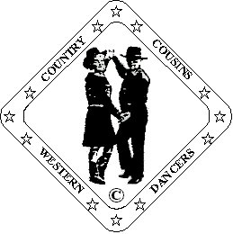
Ron & Ann Williams.
D & G Fully Qualified Instructors
B-W-D-A
023 9234 1758 ronannwilliams@ntlworld.com

Tricky Kicks

Partner Dance (64 Count)

Choreographed By Ann Williams. “Country Cousins Western Dancers” 03/09

Music: “One Dance With You” By Vince Gill. 138 bpm ECS.
CD “High Lonesome Sound”
“More Of Your Love” By The Derailers. 144 bpm.
CD “Here Come The Derailers”

Beats/Step Description.
Open Double Hand Hold. Man facing O.L.O.D. Lady facing I.L.O.D. Opposite feet throughout.

Side. Together. Side. Touch. Side. Together. Side. Touch.
1-4 Step left to left side. Step right beside left. Step left to left side. Touch right beside left.
5-8 Step right to right side. Step left beside right. Step right to right side. Touch left beside right.

¼ Turn. Touch. Back. Touch. Walk x 3. Kick.
9-12 Turn ¼ turn left and step left forward. Touch right beside left. Step right back. Touch left back.
Release mans’ left hand, ladys’ right.
13-16 Walk forward on left, right, left. Kick right forward.

Step. Kick. ¼ Turn. Kick. Step. Kick. Step. Touch Back.
17-20 Step down on right. Kick left forward. Turn ¼ right stepping onto left. Kick right to right.
Rejoin in Open Double Hand Hold. Lady kicks her left between mans’ legs.
21-24 Step right beside left. Kick left between ladys’ legs. Step left beside right. Touch right back.

Step. Brush. ¼ Turn. Brush. Walk x 3. Brush.
25-28 Step right forward. Brush left forward. Turn ¼ left stepping onto left. Brush right forward.
Release right hand, raise left, lady passes under raised arms.
Lady now on mans’ left side holding inside hands.
29-32 Walk forward on right, left, right. Brush left forward.

¼ Turn Sway. Sway. ¼ Turn. Hold. ¼ Turn Sway. Away. ¼ Turn. Hold.
33-36 Turn ¼ right step and sway onto left. Sway right onto right. Turn ¼ left stepping onto left. Hold.
You turn back to back and then return to L.O.D. holding inside hands
37-40 Turn ¼ left and sway right hip onto right. Sway left onto left. Turn ¼ right stepping onto right. Hold.
You turn to face partner touching and then back to L.O.D. still holding inside hands.

Rocking Chair. Walk X 3. Hold
41-44 Step and rock forward on left. Recover onto right. Step and rock back on left. Recover onto right.
45-48 Man: walk forward on left, right, left. Hold.
Lady: Turn ½ turn left stepping on right, left, right. Hold.
Raise joined hands over ladys’ head as she turns, offset left shoulder to left shoulder. Rejoin mans’ right, ladys’ left hands at waist level.

Vine Changing Sides. Hold. Rock. Recover. Step. Hold. (Lady: Step. Pivot. Step. Hold)
49-52 Man: Step and cross right behind left. Step left to left side. Step right beside left. Hold.
Lady: Step left to left side. Step and cross right behind left. Step left to left side. Hold.
You have now changed sides, right shoulder to right shoulder.
53-56 Man: Step and rock back on left. Recover onto right. Step left forward. Hold.
Lady: Step right forward. Pivot ½ turn left. Step right forward. Hold.
Release left hand, raise right over ladys’ head to end holding inside hands.

Rocking Chair. Step. Pivot ½ Turn. Turn ¼. Touch.
57-60 Step and rock forward on right. Recover onto left. Step and rock back on right. Recover onto left.
61-64 Step right forward. Pivot ½ turn left. Turn ¼ left stepping right to right side. Touch left beside right.
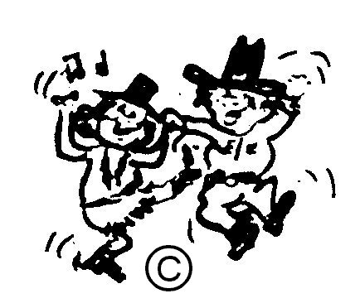
Release hands and rejoin in Open Double Hand Hold.
Now facing partner ready to start again.

HAPPY DANCING

